Science Fair
Judging Rubric

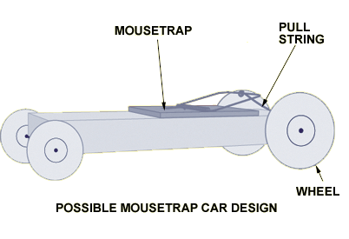
Student Name:
Grade:
Place Speed:
Place Distance:

Source: http://www.pbs.org/saf/1208/images08/ti1a.gif

 |  | Score
Task | Max 45 Points
Completed required 25 feet | Up to 25 points
Bonus: Won class distance or speed. | + up to 10 for each
2 points for 3rd, 5 points for 2nd , 10 points for 1st
Quality | Max 40 Points
Well built can last multiple trials | 0-20 Points
Showed originality in construction or design | 0-20 Points
Improvement | Max 35 Points
Has recorded Data that shows multiple designs and attempts | 0-20 Points
Car is better in distance or speed than first trials | 0-15 Points
Total | Out of 100 Max 120

