PCA Science & Technology Supply Sheet

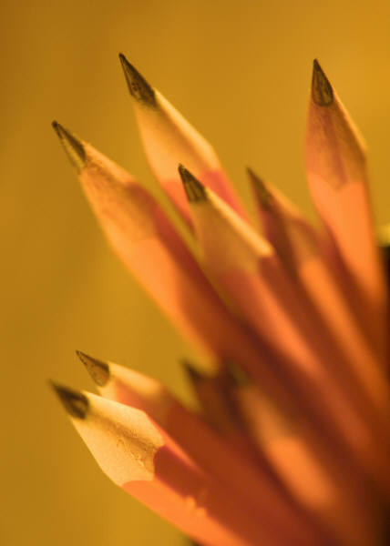
Title of Course 1-8: Science Inquiry, Math Applications & Creative Thinking

Science Materials needed for Class and Homework: For 1st – 8th grades:
- Their own scientific calculator *( with, Sin (e) and Cos (ine), buttons). I got a nice one from Radio Shack for $9.99 on sale, a Casio or TI type Calculator can cost around $20 but you shouldn’t get one that cost more than that unless you want to. CVS Scientific calculators can cost under $10, but they don’t last very long.
- A 12 inch ruler with centimeters and inches.
- A 1 subject notebook-preferred color – green for the first semester.
- A Folder with pockets for worksheets and homework.
- 25 or more5x8 ruled index cards. (4x6) can be used if necessary but they may be used up quicker. 5X8 is preferred.
- A snap or key ring for index cards.
- 4 White board ( dry erase) Markers for In class work. They can be thick or thin and can be any color ( as long as it can be seen).

*Note calculator should be brought to every class and brought home when work calls for it. It will not be allowed to be used in class to do simple computations, or to take the place of memorization of basic facts such as times tables.

Other items that are optional include a pencil sharpener (that cuts down on students getting up), a protractor with an angle finder, a hole punch for index cards.

