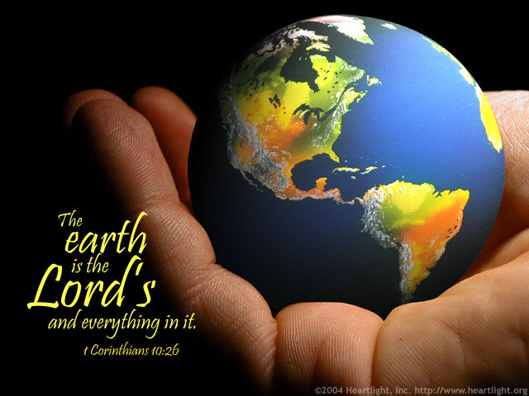
Mr. Dixon’s Science Course Plan Overview for all grades…

The Spirit of Science and of the bible is to let things be confirmed by 2 and 3 witnesses. As an experienced teacher, I expect students to be the head and not the tail in all that is Scientific. This means making them prepared to make the extraordinary ordinary… Like David Defeating Goliath, we can defeat many Goliaths as a student body, not just with the “best and the brightest” but with every student. Those Goliaths are real trials, and like a team needs a game, we will be using external and developmentally appropriate measures to see where we really stand.

Our class Motto Describes How this can happen: Keeping the PACE- Parkside’s Academically Courageous Enterprise
Boldly Going where God wants us to, We take Risks in learning what’s new, We never say I can’t but instead I DO! We drive out fear and support each one, We stretch ourselves and thrive on Fun! We see problems as opportunities in work clothes, We love to learn and keep each other on our toes! We understand and apply knowledge with depth and clarity, We seek God’s wisdom to make the Extraordinary- Ordinary!

Rationale: Many High Schools now teach Physics in the 9th grade. It is the most concrete of the sciences and developmentally appropriate. The issue historically has been the math needed for the course, but the course can be taught conceptually. The amount of material in that course is also a bit overwhelming. In getting students ready for it longitudinally, it gives students more time to become familiar with language, as well as give them confidence when taking the test. We will cover all the other requirements for Massachusetts frameworks, but keep the content as simple as possible with as much depth and problem solving skills. When working in Boston Public schools, I did my PhD research on acceleration and received my national AP teacher of the year award working with students whose skills in math and science were often below the level of average students in the 6th grade at PCA. The students were able to progress effectively and some even passed the AP exam because of high expectations and high levels of support.
Methodology: To bring students to a higher level or to bring students who are behind up to where they belong requires Acceleration. I view Acceleration as introducing primary topics, and especially problem solving skills early on in the lives of students so they can make connections, build their confidence and have more time for those Ahah moments. Essentially- Simplifying curriculum in order to speed up, but at the same time slow down. I also feel that learning should be in a fun hands on way that connect to real world expectations and skills- such understanding the language of tests- like the MCAS or TIMSS, or the college level SAT’s.
Academic Goals and Benchmarks:
- The Capstone goal for the 7&8th grades sets a standard for the rest of the courses… The SAT Subject Test in physics. Because we have 2 years to prepare for it, that allows more time, less pressure, more depth. It is like our game and gives us something concrete to prepare for.
- A benchmark for all grades will be the Massachusetts Frameworks in both Mathematics (especially for number sense, estimation and problem solving) and Science. This impacts the 1st and 2nd grades because they are in the first stages of preparing for the content and language for such a curriculum.
- I have 70 basic Concepts for both Mathematics and Science that include topics such as Classifications of Animals, The solar system, Types of Matter, and also include Estimation, Scientific notation, Measurement, conversion, Newton’s Laws, Anatomy, Parts of Plants, Summation notation, etc. These topics are introduced at various times then Revisited. These cover the concepts in the Massachusetts frameworks, and beyond to support the capstone goals.

Pedagogy: 
SMART Practices

Technique

Corresponding Curricular Practice

Academic Needs Addressed

Spiraling
(with Exposure to what is next)

Early introduction of material and problems solving at developmentally accessible levels, Revisiting material until it is internalized. Weaning students off of teacher dependence.

Basic Skill Development, Curricular content development, Confidence Building.

Memorization

Classifications, 4 types of matter, 5 types of living things, Density, momentum equations, Speed Quizzes,, Intentional feedback, Weaning students off of teacher dependence, Group Poster Development.

Confidence Building, Work ethic development, Basic skills development, remediation and maintenance, Curricular content development

Algorithm

15% problems, Fermi Estimation Questions, Weaning students off of teacher dependence, Group Quizzes, Group Problem-solving, Using current content to address basic skills.

Curricular content development, Test language and problem-solving literacy, Confidence Building,

Recapitulation
(not spiraling seeing the same things again for internalization)

Speed Quizzes, Intentional feedback, Weaning students off of teacher dependence, TIMMS tests, Group Quizzes, Priming the Pump, Affective Mantras, Using current content to address basic skills.

Work ethic development, Test language and problem-solving literacy, Group awareness and positive interaction around “Truth”- Where students really are with material.

Test-Based Problem-solving

Weekly Sheets sets, Practice tests, Fermi Questions, preaching & Coaching.

Test language and problem-solving literacy, Group awareness and positive interaction around “Truth”, Curricular content development.

What I have seen so far- Over the past year and change, I have seen outstanding growth in many students. Confidence is being built overall, and students who are really beginning to understand topics beg me for extra problems. Nothing can make me more happy as a teacher. Some students who have struggled are really finding their confidence as they see things for the second or third time. What I hope to see is for students to steadily progress on short assessments based on Mass Frameworks.

What you can do to help- 1. Please help us fulfill our motto, keeping things positive, not allowing students to hear or say to themselves that work is too hard or they can’t do it. 2. Be patient… this is a long term effort. One of my weakest students last year became one of my best, when she finally understood she could do the work well. Students get such breakthroughs at different times. 3.Please allow students to answer the homework questions the best they can (for 1st grade students may need help reading the question) on their own. If students as a group are not understanding I will adjust , but if they get most of the questions correct I will assume they understand. 4. Help with projects. We do projects and demonstrations regularly in class- if you have materials or want to do experiments with them at home or to bring to school that is welcome. 5. I am asking students to read around their favorite science subject as well. Encouraging reading of anything science related is appreciated.

Grades: My goal is to drive out the fear of grades in the lower grades especially. For 1st and 2nd , I will be looking for basic understanding and improvement over the year, as well as participation in class and in our many hands on projects. For 3rd-8th Grades will be based 30 % Based on Mastery (skill sheets and quizzes), 20 % on Term assessment, 20% on project, 30% homework.
Curricular Highlights by Grades:
Grades are paired to simplify and build in Recapitulation.
Detailed list of standard curriculum by grade is available on request. What is stated here is the highlight of that standard curriculum with additions for acceleration.

1st & 2nd grades:
Content: Getting our Bearings: Classifications-Understanding how things are named, Using the moon to locate the sun, Compass Directions, Parts of flowers, 4 types of matter, 5 types of living things, Major parts of the Solar system, Major parts of an atom, 2 major types of animals, the other subgroups of animals and their characteristics and habitats. Distance, Mass, Time & Temperature in MKS units (Metric System). How God wants us to be good stewards of all He has shared with us. Also finding patterns in numbers and in our surroundings, & summing consecutive numbers.

Demonstrations/ Hands on Projects: Here are just a few of the many hands on projects we will be doing this year: Implosion of a soda can, Dancing Raisins, Comeback cans, Identifying vertebrates and invertebrates, identifying the parts of the earth, rockets, reading basic weather maps, identifying trees from their leaves, How light refracts to make colors, Use of Microscopes, as well as many used last year from robots to chemical reactions and others.

3rd & 4th grades:
Content: From Sea to Shining Sea: Here are just a few of the many hands on projects we will be doing this year: In addition to previous curriculum, Fermi estimation problems, Classifications-of explore six of the climates in United States: Mediterranean, Grassland, Highland, Humid continental, Humid subtropical, desert climate and the animals and plants that live in them, Molecules ( especially H₂0), Water-buoyancy, the water cycle, types of clouds, waves and tides; Forces, Newton’s 3 laws, Velocity and Acceleration, Graphs of Data, Density, Parts of the earth, causes of Volcanoes earthquakes, Ring of fire, types of soil, parts of the body, Food Webs, Extinction, Electricity-Static and Circuits, the animal kingdom- sponges, cnidarians, worms, mollusks; arthropods and echinoderms; fishes and amphibians; reptiles and birds; mammals, Collisions in 1 dimension. How God wants us to be good stewards of all He has shared with us and active steps we can take to walk in that stewardship.

Demonstrations/ Hands on Projects: Here are just a few of the many hands on projects we will be doing this year: Implosion of a can, Determining Density, buoyancy, Identifying Forrest vs Desert plants and animals, identifying land formations and definitions, rockets, reading basic weather maps, identifying parts of waves, making simple circuits and others.

5th & 6th grades:
Content: The Little Things Matter: In addition to previous curriculum, Classifications-of parts of the cell, systems of the body, ecosystems; biomes; living resources; land, soil, air and water resources; energy resources: fossil fuels, nuclear, and energy conservation, Basic Optics, Basic thermodynamics, Basics of Genes and DNA, Punnet Squares, Chemical Equations, Avogadro's Number, Cells, Mitosis, Gravity. How God wants us to be good stewards of all He has shared with us and choosing specific people to write or ideas to do at school that can support that effort.

Demonstrations/ Hands on Projects: Here are just a few of the many hands on projects we will be doing this year: Determining Density, buoyancy, Identifying parts of a cell, Linear expansion, Air Rocket, Mitosis Dance, Vectors in 2 dimensions, collisions in 2 dimensions, letter to congressman or scientist, and others.

