Rules, Ranks and Regulations for
PCA Technology Club:

Galaxy Class USS Enterprise NCC-1701-D
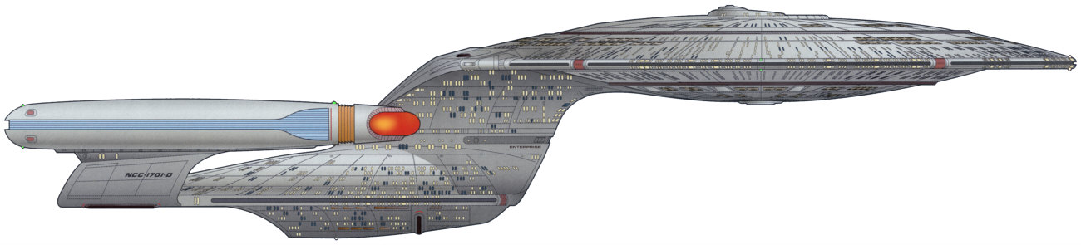Technology Club will be using a set of Rewards and Goals for members to reach for, as well as demerits that will limit their movement up in rank. This is designed to build up leadership skills as well as Mastery of Skills needed for mental development, such as chess- to see how things work together as well as rules of how things work, as well as content development- such as learning electronic components and what they do, learning how to use gears, motors, solar panels, multimeters etc. Authority is very specific and respect for authority is a must to participate in the club, primarily because of safety. You must listen to those in charge over you and remember the basic safety rules of the lab. No running, Do not touch any science equipment without permission or necessary supervision, in addition to any rules specific to what we are dealing with at the time. For this year we will have a special group of “special Ops” (Special Operations called Gideon’s Crew)… They represent the highest ranked members who will focus on teams for competitions.

Some Goals for the year:
- Make Electronic Kits
- Fund raisers – Selling kits & electronic Christmas trees as much as they cost… at Christmas auction…
- Selling T-shirts for Our Competition at the Tech Fair.
- Chess/game/ puzzle a thon… Getting sponsors and teaching all comers how to play and having games being played as well… ( a double elimination tournament…)
- Solar car races for prep for May 2007
- A trip to 2.70 at MIT (Mech Eng. Wire controlled robots) (or 6.270- autonomous robots) Contest will be the reward for members in good standing.
- A Race Challenge to coincide with Science Fair.
- Others:

Organizational Chart:
President of the Federation- Allison Matthews
Oversight of Entire operations

Fleet Admiral- MD² Overall Adult leader of Science and Technology club
Over different components of Tech club (maybe Chess, Math, Support of School) etc. get started then a need for general oversight…

Admiral-. Ruth Wong Adult leader of Science and Technology club. Let’s welcome her with open arms…

Commodore- Highest possible rank for Student- a captain of captains.

Captain- Leader of One team (usually given a name above…)

Commander- Selected leader, with proven leadership skills, able to support each level below them, but also a commendable person of Christian Character.

Lieutenant commander and below- See How to obtain a rank Below.

Provisional rank- Rank assigned to a person before a test is given to allow for full fledged rank. This gives them some command responsibilities usually needed before tests can be done.

Phrases-
You have the Comm… Authority is delegated to next in command and They are in charge, While Higher in command is away…

Make it so… Given a task, a leader is asked to accomplish it the best way they know how.

Fleet Admiral (FADM) Admiral (ADM) Vice Admiral (VADM) Rear Admiral (RADM) Commodore (COMO)
- MD² RW

Captain (CAPT) Commander (CMDR) Lieutenant Commander (LCDR) Lieutenant (LT) Lieutenant, J junior Grade (LT JG) Ensign(ENS)

Provisional Ranks- same as above but with a line below…

How to obtain a rank; (Every New member begins at an Ensign but can move up quickly by skipping exams if they would like…and are able)
- Direct appointment by an Admiral.
- Emergency/ temporary promotion if a leader is out for an extended period of time.
- Go through a test for leadership and skills needed to lead in Technology club.
Test to include:
  - Going from Ensign to LTJG- Knowledge ( being able to identify the pieces, and how they move- to En passant) of Chess*, being able to make a cube with Klikkos, not a disruption to class AND all Demerits Cleared…* Chess is required because it supports systems thinking- how things work together- how we work together as a team, protect each other etc, and how even different parts of circuits play different roles for a purpose.
  - ii. Going from LTJG to LT- In addition to the above…Knowledge of resistor code, Knowledge (being able to identify and tell what they do) of basic electronic components (resistors, Capacitors, transistors, LED’s), ability to solder, Able to use a multi-meter to measure amps and volts, ability to have noticeable self control when needed, brings materials to class (like rank insignia, kits, etc.), gets to class on time.
  - Going from LT to – LCDR. In addition to the above…Able to build and trouble shoot an electronic kit, Knowledge of basic sensors, motors, glue guns, clean up expectations (time and quality), gears, How to construct a wire controlled robot. Able to command the respect of other members of the Club and lead group when other people are not around…As seen by students being busy working or constructively interacting, and not playing around while they are in charge.
  - Going from LCDR-CMDR. In addition to the above… Their love for God is evident, and leadership skills are developed. Able to learn new Technology based tasks quickly, able to communicate with potential partnerships and funders what we are all about- with enthusiasm.
  - Going from CMDR- CAPT. They are elected- Chosen by the admiral to lead a specific team to accomplish specific tasks. Supports his team members, willing to sacrifice for them, keep them safe physically as well as emotionally, maintains high expectations of those under their command.
  - Going from CAPT-COMO. When teams are set and the numbers require a means support the supporters ( a captain of captains), a Commodore will be again Chosen to lead. They may also still be a Captain.

Other Ranks are established as needed. One can be demoted, if they do not maintain the requirements of their position, or gain excess demerits and become a negative example to those under them.

Demerits are obtained by directly disobeying a rule of the technology club- or disobeying one in authority over them, Disrespect of a commanding officer is 3 (or more) demerits. Disrespect of any other member of our team requires at least 1 demerit, and a written apology.
Demerits can be worked off by cleaning up and setting up the room, extra research on a topic given by their commanding officer/Admiral.

Basic Rules of Technology.
- Follow directions precisely and quickly.
- Get to club on time. You will get on Demerit if you come up late (unless you are with the Admiral or have a valid excuse.
- Food (snacks) can not be eaten in the room until after 4:30. We waste a lot of time eating before technology. You usually don’t eat snack at extended care until about 4:30 or so. If we do have a snack it must be at one of the two back tables and you must clean up after yourself.
- NO RUNNING in the room.
- DO NOT TOUCH OR MOVE ANY EQUIPMENT without the Admiral’s (or a delegated leader’s) Permission.
- Use Markers only as needed…
- Clean up until The room is better than you found it.
- Have Fun, Be Safe, Share equipment, let Admiral and commanders know what you need, and what tasks you would like to do.

Basic Responsibility of officers- get us started on time with reverent prayer, getting us to keep on task- not distracted, A list of Demerits is kept, Promotion exams are given as needed on first tech week of month, Materials are set up and put away in their proper places.
Beginning in December, Members will be responsible for their own rank insignia to be worn in class every Tuesday or a Demerit will be given. Officers responsible for doing checks right after prayer.

