PCA Technology Fair- 2008
Expectations
Updated: Monday, January 07, 2008

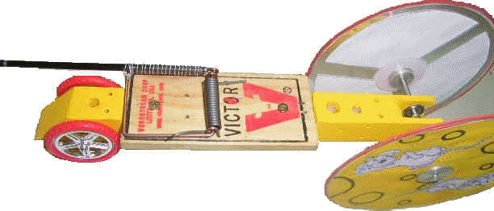
Expectations for Mousetrap Car Racer: The 2 goals of the Mousetrap car race is for a student learn and utilize engineering techniques by designing and working with their hands to create a device that will transport a homemade Parkside Christian Academy flag (at least 2 inches wide by 3 inches long) Half the distance of the basketball court (~40 feet), faster than their opponents. The other goal is to see how far ( and straight a car can go).THE MOUSETRAP CAR RACE IS ON Π DAY –FRIDAY MARCH 14, 2008.

Expectations of Mouse Trap cars:
- They must fit in a 25 inch x 25 inch x 25 inch box. ( note a little bigger than last year)
- They must weigh less than 2 kg (~4.4 lbs)
- ***No external Ramp, rubber bands, etc. can be used to propel the car. The only source of power for the car must be one mousetrap.
- The entire device must move the entire distance of the race. If any parts are left behind, then the position of the fallen parts are the official position of the “flag”.
- A name should be given to your device and displayed at the top somewhere on the device.
- Students must move their home made Parkside flag via a wheeled vehicle 25 feet utilizing the propulsion energy of a mousetrap and or 3 standard rubber bands that will be distributed.
- For their 3 page Paper ( NO BOARD NEEDED FOR CAR), students must include initial design, 6+ vocabulary words, How they used the engineering process and improved their car over time, such as aerodynamic transfer (movement of air), kinetic energy transfer for a ball that rolls down a track, etc. A chart of best speed over 25 feet should be given for 3 different attempts over 3 or more weeks, so improvement ( and experimentation) can be charted.
- There will be an official test then a set of official races for each student’s device. It will judged on performance to complete the 25 foot track based on its first official test. You can score a perfect score for a test below 4 seconds that completes the entire track. If the first test does not succeed, then a second test will be given, after which it will be considered non-performing. Keeping things simple and with high quality will help with multiple races. The winner of the contest, must win their bracket (only one race per pair of cars during the bracket rounds) and then the championship (in a 2 out of three race). Winners of each round are the cars that complete the course in the shortest time. In case neither car completes the course, the car that goes farthest in 30 seconds is the winner of the heat. There will be special awards for overall speed, creativity and quality.
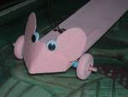
- Students will be judged based on the Mousetrap car Rubric –scoring sheet.
- A final draft of a 3-page typed paper will be due Tuesday March 4th that includes:
  - Introduction: including background research of types of energy used, important vocabulary such as lever arm, spring force, potential energy, etc.
  - Initial Design, revisions and Data Chart. Drawings and explanations of what you planned to do initially and how that changed over time, as well as speed.
  - Engineering Procedure: An explanation of what you did and how you utilized the PDSA (PLAN DO STUDY ACT) Cycle to get your car to work and to improve it.
  - Conclusion: including, what challenges they faced doing the project, and how you came to your conclusions, and what you learned through the process of doing this project.

