Course Outline for
PCA Theology 20
Christianity and Comparative Religion:

- The basics of Religion in General: 5 Categories, Ultimate concern, Faith, Grace, Mercy, Worship, Praise, etc.

- Abrahamic Religions- In General, an overview and review
  - Judaism
  - Christianity
  - Islam
  - Other Major Christian off shoots

- New Testament Christianity- More Specifically

- Overall Christian History and some denominations.

- Other World Religions( for example, *Hinduism, *Buddhism, Sikhism, *Taoism, Confucianism, Atheism/communism, Zoroastrianism, Shintoism, Confucianism, Jainism, Indigenous faith, Rastafarianism, Wickenism, Scientology, Mormonism, Jehovah’s Witnesses and *Judaism and *Islam are also possible) * are faiths that must be covered by students in each class.

Outline for looking at the Religions
  - Major Founder(s)
  - Date of Origin
  - Major Branches
  - Demographics (what is it’s rank in the world, how many, where are they located, etc.)
  - Time line of major events, and expectations ( future events)
  - Major beliefs theologically ( view of God, man, goal of religion)
  - Major beliefs regarding practices ( for example how they pray, treat women, treat other social ideas, etc.)
  - Major Holidays
  - A sample of a practice they have.
  - How they are similar and differ from historical Christianity
  - 3 Questions you would like to ask someone of that faith
  - Your overall impressions of the faith and how it helps you understand your faith better.

Comparative Religion Notes:
Christianity
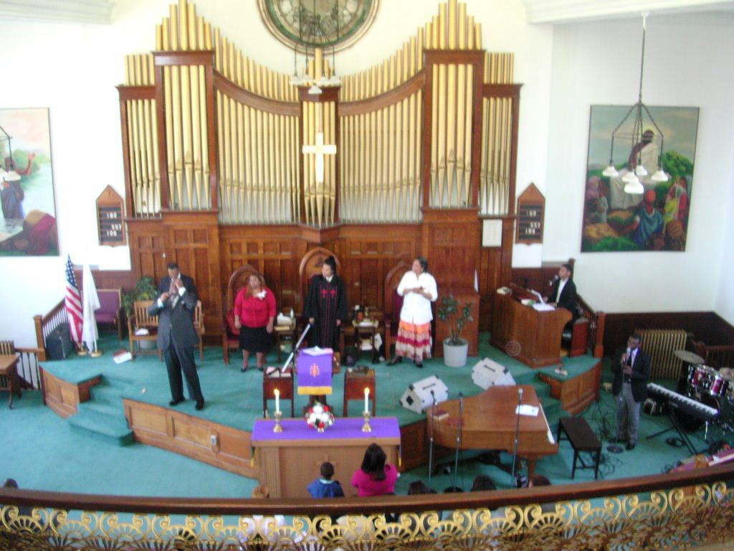

Definitions For Religion:
Ultimate Concern, Threat, Promise and Demand of U.C.
Worldview
5 Categories: Doctrine of God, Doctrine of Man, Doctrine of Salvation, Ethics, Problems of being Human
Basics: Atonement, Faith, Grace, Mercy, Praise, Worship, etc.

Important Christianity Dates:
400 Years of Silence the time between Testaments…Old and New.
4BC- About when Jesus was Born
29 AD- About when Jesus Died
70 AD, Titus Destroys the Temple as Jesus prophesied
1054 AD- Great Schism between Catholic Church and Orthodox Church
1095 AD- First Crusade,
1456 Guttenberg’s First Bible on Printing press,
1740- Great Awakening in America,
October 31, 1517 Ninety-Five Theses –Initiated Protestantism
1611 KJV first Published,
1908 Azusa Street,-The beginning of the Current Pentecostal movement
1962 Second Vatican Council, Catholic Church modernizes
Others?

Christian Holidays- The Christian Calendar
Carnival, which comes from a Latin phrase meaning "removal of meat,"
Shrove Tuesday ( Fat Tuesday- Mardi Gras) ("shrove" is an Old English word meaning "to repent")
Ash Wednesday
Lent
Maundy Thursday
Good Friday
Easter (the first Sunday after the first full moon after Vernal equinox ~March 21)
Pentecost (the fiftieth day after the beginning of Passover- a Jewish festival of first Fruits)
All Saints Day ( a Catholic Holiday)
Advent
Christmas

Major Branches: Source http://www.adherents.com/adh_branches.html#ahm

Major Traditional Branches of Christianity
(mid-1995; source: Encyclopedia Britannica)
Branch | Number of Adherents
Catholic | 968,000,000
Protestant | 395,867,000
Other Christians | 275,583,000
Orthodox | 217,948,000
Anglicans | 70,530,000

Major Denominational Families of Christianity
(This table does not include all Christians. These numbers are estimates, and are here primarily to assist in ranking branches by size, not to provide a definitive count of membership.)
Branch | Number of Adherents
Catholic | 1,050,000,000
Orthodox/Eastern Christian | 240,000,000
African indigenous sects (AICs) | 110,000,000
Pentecostal | 105,000,000
Reformed/Presbyterian/Congregational/United | 75,000,000
Anglican | 73,000,000
Baptist | 70,000,000
Methodist | 70,000,000
Lutheran | 64,000,000
Jehovah's Witnesses | 14,800,000
Adventist | 12,000,000
Latter Day Saints | 12,500,000
Apostolic/New Apostolic | 10,000,000
Stone-Campbell ("Restoration Movement") | 5,400,000
New Thought (Unity, Christian Science, etc.) | 1,500,000
Brethren (incl. Plymouth) | 1,500,000
Mennonite | 1,250,000
Friends (Quakers) | 300,000

