Name/ Grade: / Date:
Parkside Science and Technology

Weekly Sheet
Grades 4-8, Due Thursday(4th Grade), Friday (5th -8th Grade)

Science Content Questions of the Week

- A 15 sided figure is called?______________________
- Draw a 15 sided figure:

- What is the name of the hard outside of a seed?_____________________
Can you draw it?

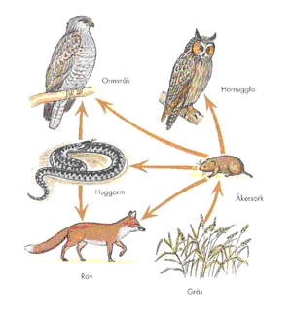
- In the bible is says that you get out what you put in- your reap what you sow. What do you get out if you practice something you like doing?__________________________________________________________________________________________________________________________________________

5. If the grass were killed off for some reason in this food web, which organism would be hurt the most? A. All B. Fox C. Hawk D. Mouse Circle 1
- a. Pentane molecule made up of how many Carbon atoms?
b. Pentane had how many Hydrogen atoms? .
c. What is the Chemical Formula for Pentane? How many atoms is this?
- $$\sum_{i=−2}^{i=\text{18}}{i}=$$
Show your work here….

Bonus $\sum_{i=2}^{i=8}{i^{2}}=$
- If Displacement D= 15t⁷, then V = ;
a. D= 5t¹⁶ V= ; V= 36t¹¹ : D= ; A= 30t D= ;

9. a. 11101₂= ₁₀ = ₈
b. BEE ₁₆ = ₁₀ = _{2 (bonus)}

b. Make2 of your own Conversion questions: and give answers

10. a. Name these whatzits:
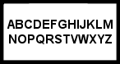 ________________ 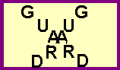 __________________

b. What comes next:
7, 5, 1, -5____, Bonus: ____, ________, ________
  - Resistor code/Scientific notation
What is the value of an Blue (6), orange(3), red (2), resistor?
a. 632 ohms b. 6,300,000 ohms c. 6,300 ohms d. 36 ohms Circle one

d. Bonus-Fermi Estimation Question: Estimate how many minutes of TV have you watched in the past month? Show your work..

