Name___________________________ Grade: ______ Rank:
Parkside Science Weekly Sheet # 15
Experiments- Charts, Graphs & Diagrams
Due Friday

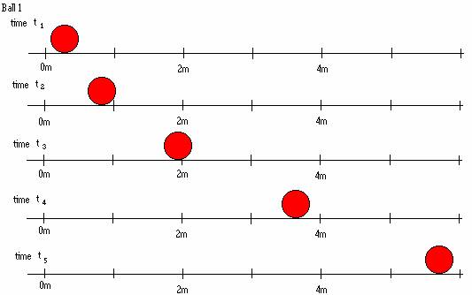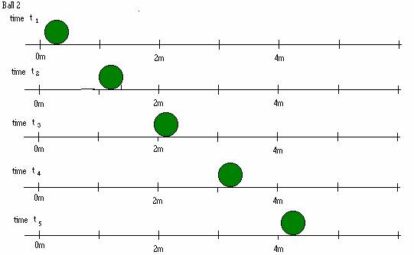
1. “Photos” of a red ball speeding up “Photos” of a green ball …
a. speeding up, b. slowing down, c. moving at constant speed, d. stopped ?
Circle one
2. What kind of tree will grow best in a desert? circle one
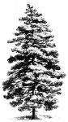
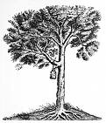
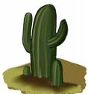
a. Leafy Oak tree, b. Tall pine tree, c. a Cactus d. a Fern ?
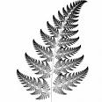



- On a common Harp are about 34 Strings. They range from very short to very long. The Pitch ( note high medium or low) a string can make is based on it’s ________________?
  - Length b. Thickness c. Time of day Circle 1
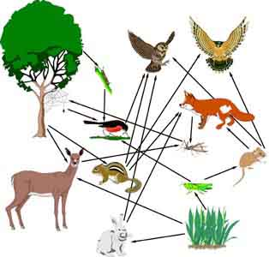
- If the grasshoppers were killed off for some reason in this food web, which organism would be hurt the most? A. Mouse B. Grass C. Deer D. Robin Circle 1
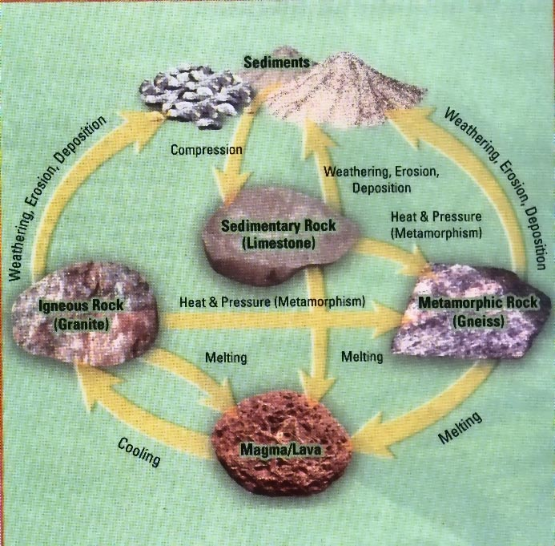
- When layers of earth get pushed under each other ( subduction) rocks often melt and turn into what?
- i. H₂O is a water molecule made up of how many atoms?
a. One b. Two c. Three d. six Circle one
ii Octane has how many atoms? __________
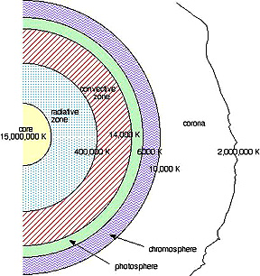
- Which part of the sun is the hottest? A. Core B. Photosphere C. Chromosphere D. Corona
- $$\sum_{i=−5}^{i=\text{15}}{i}=$$
(bonus for 1st grade) Show your work here….

- If Displacement D= 5t⁶, then the
slope = ;
Bonus: Try these for other hot shots:
a. D= 4t⁸ slope= ; D= 8t⁹ slope= ; D= 12t¹² slope= ____;
b. if V= 56 t⁶ D = ?
10.Which word is the odd one out:
First Second Third Forth Fifth Sixth Seventh Eighth ?

 _________________  ______________________

______________ __________________

c. What comes next:
i. 21, 20, 18, 15, ____,____, _____, _____, ________
ii. 20, 14, 9, 5, ____, _____, _____, ________
iii. (Challenge-bonus), 2,3, 5, 7 ____, ____, ________, ________
  - Resistor code/Scientific notation
What is the value of an red (2), orange(3), green (5), resistor?
a. 235 ohms b. 2,300,000 ohms c. 10 ohms d. 30 ohms Circle one

d. Bonus-Fermi Estimation Question: Estimate how many pages your have read in the past year? Show your work..
Other Practice:

23₈= _____₁₀ = ______₂ = _______₁₆

FACE ₁₆= ______________₁₀

1101101101₂= _________₁₀

Period of a pendulum = ____________

