Parkside Science and Technology

Weekly Sheet
Grades 1-3, Due Thursday(3rd Grade), Friday (1st -2nd Grade)
This side Is notes and bonus- the other side is your homework.

Curricular Highlights 1st & 2nd grades:
Content: Getting our Bearings: Classifications-Understanding how things are named, Using the moon to locate the sun, Compass Directions, Parts of flowers, 4 types of matter, 5 types of living things, Major parts of the Solar system, Major parts of an atom, 2 major types of animals, the other subgroups of animals and their characteristics and habitats. Distance, Mass, Time & Temperature in MKS units (Metric System). How God wants us to be good stewards of all He has shared with us. Also finding patterns in numbers and in our surroundings, & summing consecutive numbers, learning about powers and slopes.

Demonstrations/ Hands on Projects: Implosion of a can, Identifying vertebrates and invertebrates, identifying the parts of the earth, rockets, reading basic weather maps, identifying trees from their leaves, How light refracts to make colors, Use of Microscopes and others.
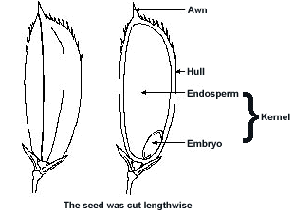
Theme of the Month: Classification – Understanding the Names of things and how they are classified.

Recall: Seeds and Flowers ( We will plant some in the late winter):

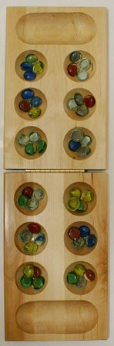
In Genesis God said that Seeds reproduce after their own Kind. We get apple trees from apple seeds.

Parts of a seed
- The embryo or germ gives rise to a seedling, which is composed of the shoot and the roots. The endosperm is a food reserve for the germinating embryo during its early growth. The endosperm is made up mostly of starch. It also contains sugars, proteins, and fats.
- The hull is the hard cover of the seed. Source: www.knowledgebank.irri.org
Mancala is one of the oldest games on earth. It comes from Africa and is a mathematical games that represents planting seeds. Do you know How to play?________

Name/ Grade: / Date:

Science Content Questions of the Week

- A 15 sided figure is called?______________________
- Draw a 15 sided figure:

- What is the name of the hard outside of a seed?_____________________
Can you draw it? (optional)

- In the bible is says that you get out what you put in- your reap what you sow. What do you get out if you practice something you like doing?__________________________________________________________________________________________________________________________________________
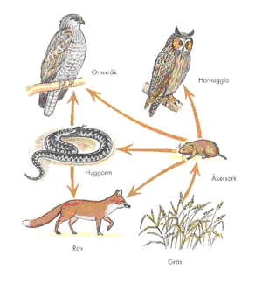
5. If the grass were killed off for some reason in this food web, which organism would be hurt the most? A. All B. Fox C. Hawk D. Mouse Circle 1
- C₅H₁₂ is a pentane molecule made up of how many atoms?
a. five b. seventeen c. sixty d. six Circle one
- $$\sum_{i=2}^{i=\text{18}}{i}=$$
(bonus for 1st grade) Show your work here….

- If Displacement D= 5t⁷, then the
slope = ;
Bonus: Try these for other hot shots:
a. D= 5t¹⁶ slope= ; D= 3t¹¹ slope= ; D= 11t¹¹ slope= ;

9. Make your own Slope Question and answer it:

10.Name these whatzits:

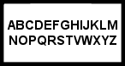 ________________ 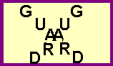 __________________

c. What comes next:
i. (1st grade) 3, 6, 9, 12, ____,____, _____, _____, Bonus: ________
ii. (2-3rd grade) 27, 25, 23, 17, ____, _____, Bonus: ________
iii. (Challenge-bonus), 7, 5, 1, -5____, Bonus: ____, ________, ________
  - Bonus Question… Resistor code/Scientific notation
What is the value of an Blue (6), orange(3), red (2), resistor?
a. 632 ohms b. 6,300,000 ohms c. 6,300 ohms d. 36 ohms Circle one

d. Bonus-Fermi Estimation Question: Estimate how many pages your have read in the past month? Show your work..

